**DIG CIRC HW3**

**O. Kürşat Karayılan**

**150140011**

𝑦=𝐹(𝑥1,𝑥2,𝑥3,𝑥4)=∪1 (0,1,2,4,7,10,13)+∪∅ (5,8,14)

|  |  |  |  |  |  |
| --- | --- | --- | --- | --- | --- |
|  | x3x4 |  |  |  |  |
| x1x2 |  | 00 | 01 | 11 | 10 |
|  | 00 | 10 | 11 | 03 | 12 |
|  | 01 | 14 | ∅5 | 17 | 06 |
|  | 11 | 012 | 113 | 015 | ∅14 |
|  | 10 | ∅8 | 09 | 011 | 110 |

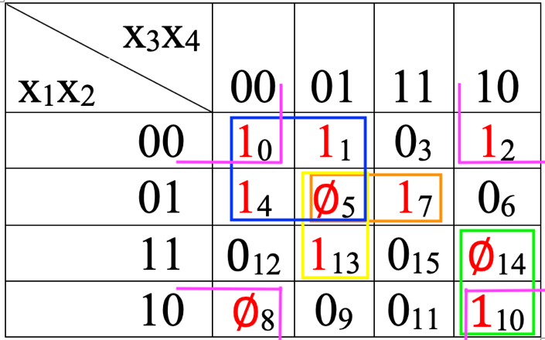

### Prime implicants = $\overline{x_{1}}x_{2}x_{4}$ $+x_{2}\overline{x_{3}}x_{4}$ $+x_{1}x_{3}\overline{x_{4}}$ + $\overline{x_{1}}\overline{x_{3}}$ + $\overline{x_{2}}\overline{x_{4}}$

### Essential ones = $\overline{x_{1}}\overline{x_{3}}$, $\overline{x_{2}}\overline{x_{4}}$ $\overline{,x_{1}}x_{2}x_{4}, x_{2}\overline{x_{3}}x_{4}$

### E = $\overline{x_{2}}\overline{x_{4}}$ D = $\overline{x_{1}}\overline{x_{3}}$ C = $x_{1}x_{3}\overline{x_{4}}$ B = $x_{2}\overline{x_{3}}x_{4}$ A = $\overline{x_{1}}x_{2}x_{4}$

### Cost and covered points table

|  |  |  |  |  |  |  |  |  |
| --- | --- | --- | --- | --- | --- | --- | --- | --- |
|  | 0 | 1 | 2 | 4 | 7 | 10 | 13 | Cost |
| A |  |  |  |  | X |  |  | 7 |
| B |  |  |  |  |  |  | X | 7 |
| C |  |  |  |  |  | X |  | 7 |
| D | X | X |  | X |  |  |  | 6 |
| E | X |  | X |  |  | X |  | 6 |

Since 1, 2, 4, 13 essential points we need to choose E, A and B, D.

|  |  |  |  |
| --- | --- | --- | --- |
|  | 1 | 4 | Cost |
| D | X | X | 6 |

Finally, we take D.

Total cost is E = 6, A = 7, B = 7, D = 6 $→$ 26

$F= \overline{x_{2}}\overline{x_{4}} + \overline{x_{1}}x_{2}x_{4}+ x_{2}\overline{x_{3}}x_{4}+ \overline{x_{1}}\overline{x_{3}}$

**Using Tabular (Quine-McCluskey) Method**

|  |  |  |  |  |
| --- | --- | --- | --- | --- |
|  | X1 | X2 | X3 | X4 |
| 0 | 0 | 0 | 0 | 0 |
| 1 | 0 | 0 | 0 | 1 |
| 2 | 0 | 0 | 1 | 0 |
| 4 | 0 | 1 | 0 | 0 |
| 7 | 0 | 1 | 1 | 1 |
| 10 | 1 | 0 | 1 | 0 |
| 13 | 1 | 1 | 0 | 1 |
| 5 | 0 | 1 | 0 | 1 |
| 8 | 1 | 0 | 0 | 0 |
| 14 | 1 | 1 | 1 | 0 |

|  |  |  |  |  |  |  |
| --- | --- | --- | --- | --- | --- | --- |
|  | X1 | X2 | X3 | X4 | 1’s amount |  |
| 0 | 0 | 0 | 0 | 0 | 0 | ✓ |
| 1  2  4  8 | 0  0  0  1 | 0  0  1  0 | 0  1  0  0 | 1  0  0  0 | 1 | ✓  ✓  ✓  ✓ |
| 5  10 | 0  1 | 1  0 | 0  1 | 1  0 | 2 | ✓  ✓ |
| 7  14  13 | 0  1  1 | 1  1  1 | 1  1  0 | 1  0  1 | 3 | ✓  ✓  ✓ |

Compare each group with below group.

|  |  |  |  |  |  |
| --- | --- | --- | --- | --- | --- |
|  | X1 | X2 | X3 | X4 |  |
| 0,1  0,2  0,4  0,8 | 0  0  0  - | 0  0  -  0 | 0  -  0  0 | -  0  0  0 | ✓  ✓  ✓  ✓ |
| 1,5  2,10  4,5  8,10 | 0  -  0  1 | -  0  1  0 | 0  1  0  - | 1  0  -  0 | ✓  ✓  ✓  ✓ |
| 5,7  5,13  10,14 | 0  -  1 | 1  1  - | -  0  1 | 1  1  0 | *  *  * |

Next step:

|  |  |  |  |  |  |
| --- | --- | --- | --- | --- | --- |
|  | X1 | X2 | X3 | X4 |  |
| 0,1,4,5  0,2,8,10  ~~0,4,1,5~~  ~~0,8,2,10~~ | 0  -  0  - | -  0  -  0 | 0  -  0  - | -  0  -  0 | *  * |

Finally, we have prime implicants from (*) terms since they can’t be simplified more.

$\overline{x_{1}}x_{2}x_{4}$ $+x_{2}\overline{x_{3}}x_{4}$ $+x_{1}x_{3}\overline{x_{4}}$**+ $\overline{x_{1}}\overline{x_{3}}$ + $\overline{x_{2}}\overline{x_{4}}$ tabular**

### $\overline{x_{1}}x_{2}x_{4}$ $+x_{2}\overline{x_{3}}x_{4}$ $+x_{1}x_{3}\overline{x_{4}}$ + $\overline{x_{1}}\overline{x_{3}}$ + $\overline{x_{2}}\overline{x_{4}}$ karnaugh

5)

a) In order to cover max 1 generating points with less prime implicant it’s better to cover with 4 units if possible.

b) We take don’t care values as 1 when we drawing rectangles to cover max amount of 1 with less prime implicant. Then we take as 0 when simplifying because we don’t need to cover them.

Let’s look at below example Karnaugh map. We a don’t care value at 8. Since we can’t include 8 to rectangles it has no use.

|  |  |  |  |  |  |
| --- | --- | --- | --- | --- | --- |
|  | x3x4 |  |  |  |  |
| x1x2 |  | 00 | 01 | 11 | 10 |
|  | 00 | 10 | 11 | 03 | 12 |
|  | 01 | 04 | 05 | 06 | 17 |
|  | 11 | φ8 | 09 | 011 | 010 |
|  | 10 | 012 | 013 | 015 | 014 |